**SEPM Assignment 1**

# What is DevOps?

DevOps is a set of practices that combines software development and IT operations to shorten the development lifecycle and provide more frequent releases while ensuring high quality. It aims to improve communication, collaboration, and integration between software developers and IT operations professionals. This allows for faster delivery of features, higher reliability, and better scalability of applications.

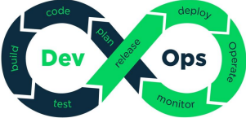

Benefits:

The main benefits of DevOps include:

* Faster time to market: DevOps practices allow for faster development and deployment of software, which means that new features and updates can be delivered to customers more quickly.
* Increased agility and flexibility: DevOps enables teams to quickly respond to changing customer needs and market conditions.
* Improved collaboration and communication: DevOps promotes a culture of collaboration and communication between development and operations teams, which helps to identify and resolve issues more quickly.
* Increased efficiency: DevOps practices automate many tasks, such as testing and deployment, which can save time and reduce errors.
* Improved quality and reliability: DevOps practices, such as continuous integration and continuous delivery, can help to improve the quality and reliability of software.
* Better customer satisfaction: DevOps practices can lead to faster delivery of new features and improvements, which can lead to increased customer satisfaction.

# 

# 

# What is MlOps?

MLOps (Machine Learning Operations) is a set of practices that combines machine learning and IT operations to enable organizations to build, test, deploy, and monitor machine learning models in a more efficient, automated, and reliable way. It aims to improve the collaboration and integration between data scientists and IT operations professionals, by providing tools and processes to help manage the full machine learning lifecycle.

This includes versioning, testing, deployment, and monitoring of machine learning models in production, as well as the ability to roll back and update models as needed. The goal of MLOps is to make machine learning models more reliable and easier to manage, in order to make them more useful in real-world applications.

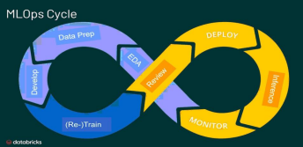

Benefits:

The main benefits of MLOps include:

* Improved collaboration: MLOps promotes a culture of collaboration between data scientists,engineers, and operations teams, which helps to identify and resolve issues more quickly.
* Increased efficiency: MLOps practices automate many tasks, such as model building, testing, and deployment, which can save time and reduce errors.
* Improved model quality and performance: MLOps practices, such as continuous integration and continuous delivery, can help to improve the quality and performance of machine learning models.
* Better model governance: MLOps practices can help to ensure that models are compliant with organizational policies and regulations and that they are fair, explainable, and accurate.
* Improved model monitoring and maintenance: MLOps practices can help to monitor the performance and behavior of models in production, and to quickly update or replace them if necessary.
* Better alignment between business and IT: MLOps practices can help to align the development and deployment of machine learning models with business goals and objectives.

# 

# What is SecOps?

SecOps (Security Operations) is a set of practices that combines security and IT operations to ensure the security of an organization's IT systems, networks, and applications. It aims to improve the collaboration and integration between security and IT operations teams, by providing tools and processes to help manage the security of an organization's IT infrastructure. This includes identifying and mitigating security risks, protecting against cyber attacks, and ensuring compliance with security regulations and standards.

The goal of SecOps is to provide a more proactive and efficient approach to security, by integrating security into the development, deployment, and operation of IT systems, rather than treating it as a separate, after-the-fact concern.

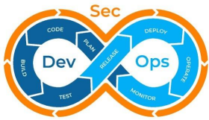

The main benefits of SecOps include:

* Improved security posture: SecOps practices can help to identify and mitigate security threats more quickly and effectively, which can help to improve the overall security posture of an organization.
* Increased efficiency: SecOps practices automate many tasks, such as security monitoring and incident response, which can save time and reduce errors.
* Improved collaboration: SecOps promotes a culture of collaboration between security, development, and operations teams, which helps to identify and resolve issues more quickly.
* Better compliance and governance: SecOps practices can help to ensure that an organization is compliant with regulatory requirements and industry standards and that it has proper governance and oversight in place.
* Improved incident response: SecOps practices can help to improve the speed and effectiveness of the incident response, which can help to minimize the impact of security breaches.
* Better alignment between security and business objectives: SecOps practices can help to align the security efforts of an organization with its business goals and objectives.

# 

# What is AiOps?

AIOps (Artificial Intelligence Operations) is a set of practices that combines Artificial Intelligence and IT operations to improve the efficiency, speed, and quality of IT systems and services. It aims to improve collaboration and integration between AI engineers and IT operations professionals by providing tools and processes that can automate, optimize, and manage the full AI lifecycle. This includes the development, deployment, monitoring, and maintenance of AI models and systems, as well as the ability to roll back and update models as needed.

The goal of AIOps is to make AI more reliable and easier to manage in order to make it more useful in real-world applications and to bring the benefits of AI to more organizations and industries.

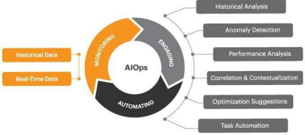

The main benefits of AIOps include the following:

* Improved IT operations performance: AIOps can help to identify and resolve issues more quickly and effectively, which can improve the overall performance of IT operations.
* Increased efficiency: AIOps can automate many tasks, such as incident detection and resolution, which can save time and reduce errors.
* Improved incident detection and resolution: AIOps can use machine learning and artificial intelligence to detect and diagnose incidents more quickly and accurately, which can improve the speed and effectiveness of incident resolution.
* Better IT operations visibility: AIOps can provide more comprehensive and real-time visibility into the performance and behavior of IT systems, which can help to identify and resolve issues more quickly.
* Improved automation: AIOps can use machine learning and artificial intelligence to automate many IT operations tasks, such as incident response, which can save time and reduce errors.
* Better alignment between IT operations and business objectives: AIOps can help to align the IT operations efforts of an organization with its business goals and objectives.